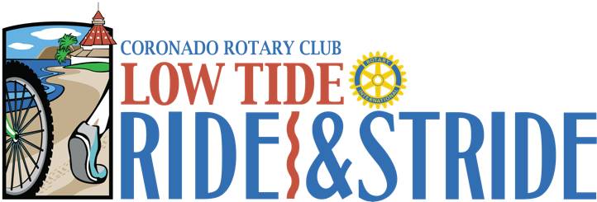
Yes! I would like to be a sponsor for the 2026 Low Tide Ride & Stride Hosted by the Rotary Club of Coronado
Company Name (As you want it listed): __________________________________________________________________________________________
Contact Person:____________________________________________________________________________________Address:___________________________________________________________________________________Phone: ___________________________ E-mail: __________________________________________________
Please make checks payable to The Rotary Club of Coronado Foundation.
c/o Low Tide Ride & Stride, P.O. Box 180487, Coronado, CA 92178-0487 Or we can charge your credit card directly:
Card Type & Number: ______________________________________Expiration Date:_____________________ Name as it appears on your card:_______________________________________________________________ Please check your choice and mail this form with payment to our Rotary Office:
_____Platinum - $10,000
_____Gold - $5,000
_____Silver - $2,500
_____Bronze - $1,000
_____Community - $300
______Sponsor a Military Family to Participate in this year’s LTRS - $100
_____Other
SPONSORSHIP MUST BE RECEIVED BY SATURDAY, June 10, 2026, FOR T-SHIRT INCLUSION
Please email a print quality logo (.tiff or .jpg at least 300 dpi) and company name as you want it listed to: StephanieJKA@gmail.com.
Low Tide Ride & Stride has become synonymous with helping organizations help people for the past 27 years. With your support, we can make it 28!
THANK YOU FOR YOUR SUPPORT | YOU MAKE ALL THE DIFFERENCE!
SPONSORSHIP LEVELS
PLATINUM SPONSOR - $10,000
- Elite Name Recognition at Race Start & Finish
- 8 Complimentary Entries
- Top Billing Recognition on Event Dry-Fit Shirt
- Signage on Mile Markers and Water Stations
- Inclusion in Coronado Eagle & Journal Newspaper Ad
- Recognition on Website
GOLD SPONSOR - $5,000
- Name Recognition at Race Start & Finish
- 6 Complimentary Race Entries
- Recognition on Event Dry-Fit Shirt
- Signage on Mile Markers and Water Stations
- Inclusion in Coronado Eagle & Journal Newspaper Ad
- Recognition on Website
SILVER SPONSOR - $2,500
- Name Recognition at Race Start & Finish
- 4 Complimentary Race Entries
- Recognition on Event Dry-Fit Shirt
- Inclusion in Coronado Eagle & Journal Newspaper Ad
- Recognition Website
BRONZE SPONSOR - $1,000
- 2 Complimentary Race Entry
- Recognition on Event Dry-Fit Shirt
- Inclusion in Coronado Eagle & Journal Newspaper Ad
- Recognition on Website
COMMUNITY SPONSOR - $300
- Inclusion in Coronado Eagle & Journal Newspaper Ad
SPONSOR A MILITARY FAMILY TO PARTICIPATE IN THE LTR&S - $100
- Helpers High: That feeling when you do something good for someone else.

